**Task 1:**

1. **Task Description**

Create a Calculator Application using React. The application should include basic arithmetic operations like addition, subtraction, multiplication, and division. It should also feature a button to clear all inputs, delete the last entered value, and calculate the result. Include percentage calculation functionality. The UI should be visually appealing and the calculator should handle user input accurately, preserving leading zeros until calculation and displaying the result.

1. **Task Output Screenshot**

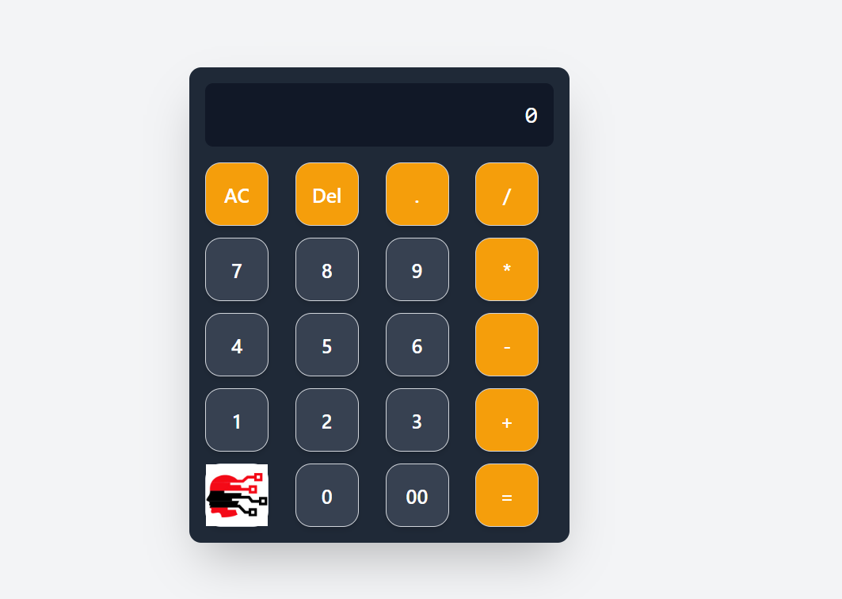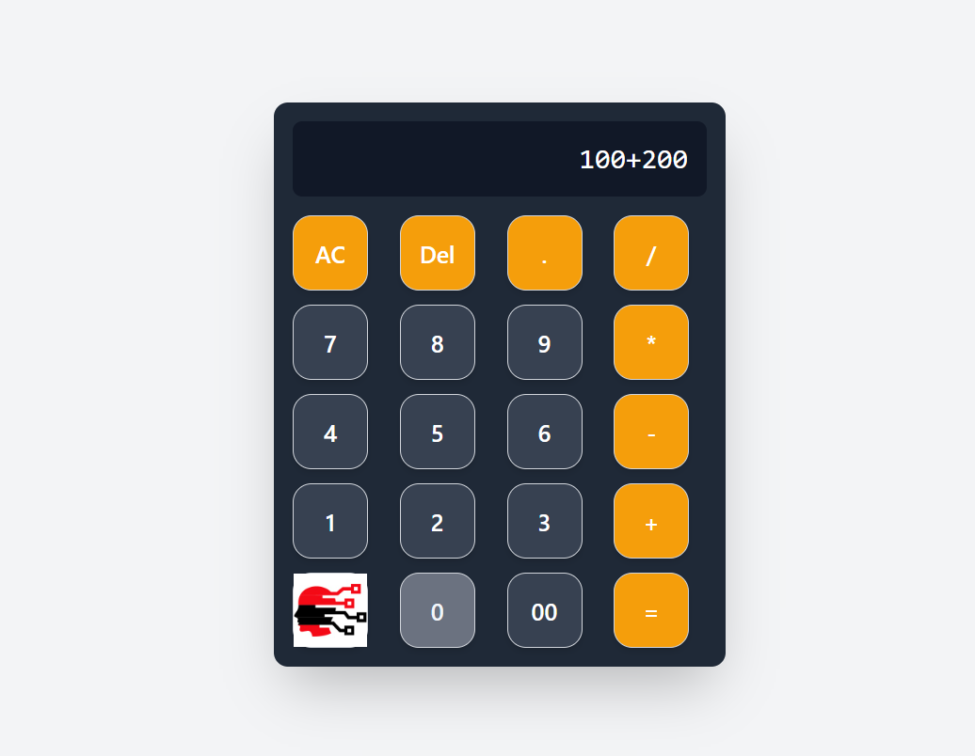

1. **Widget/Algorithm Used In Task**

* **useState Hook:** Used to manage the state for the input value and calculated result.
* **Button Widget:** Used for each button of the calculator, including digits, operators, and special functions like clear and delete.
* **Text Display:** Used to display the current input and result.
* **eval() Method**: Used for evaluating the arithmetic expression entered by the user (with caution for security).
* **Conditional Logic:** For handling the change of display after calculation and preserving the input before it is calculated.